**Practical No 5**

**Aim:** Write a program to do the following:

a) Find the vector-matrix multiplication of a r by c matrix M with an c-vector u

**Source Code:**

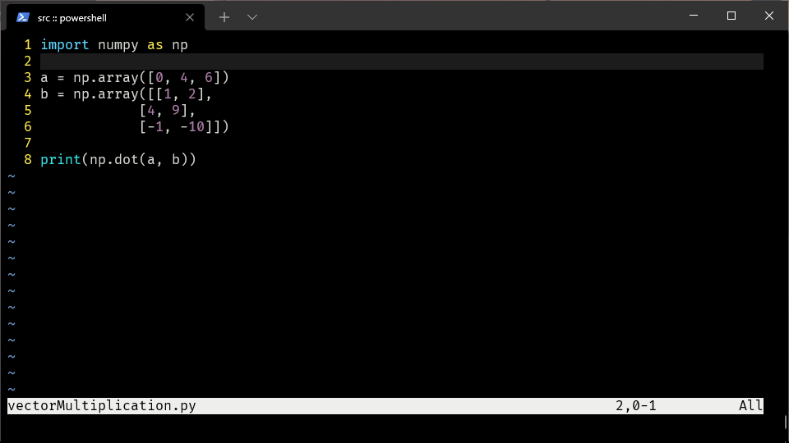

**Output:**

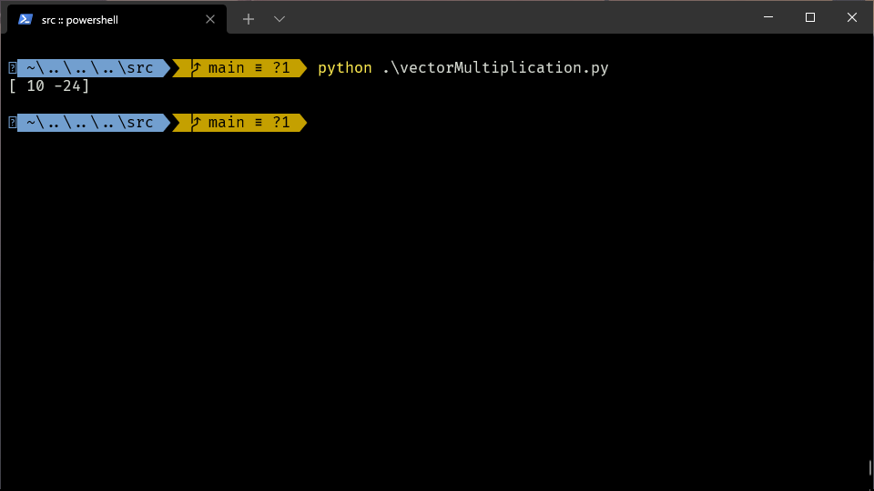

b) Find the matrix -matrix product of M with a c by p matrix N

**Source Code:**

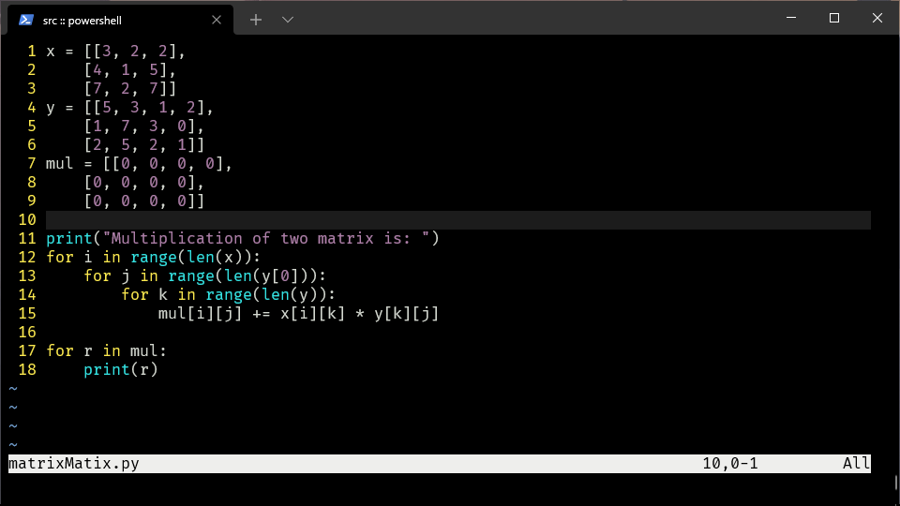

**Output:**

